CSD 302 Design and Analysis of Algorithms
Midterm, Spring 2020-21, Max Marks - 50, Time – (9:00AM - 10:45AM)
All questions are compulsory.
The answers should be written neatly and precisely.
The algorithms must be written in English-like pseudo language.
You may write the answers using pen and paper and upload a good quality image as an answer.
You are NOT allowed to use any books, class notes or any other resources to answer the questions.
Questions 1, 2 and 3 are compulsory.
You may choose to do any 2 questions from among questions 4, 5 and 6.

Name: Prakhar Rathi
Roll No. 1810110169

- Answer the following questions: [Marks: 20]
  - Does every weighted graph has a unique Minimum Spanning Tree. Justify your answer.

Answer: Every weighted graph does not have a unique MST. This is because any algorithm like Prim and Kruskal gives equal weight to edges having the same weight and if there two edges which have the same weight and form a cycle then both of them will not be picked in the MST which will lead to two possible solutions to the MST problem of a graph. For a weighted graph to have a unique solution, all weights must be distinct. Another case is when the weights aren’t the minimum weights and not all of them can be accommodated. In that case there can be multiple solutions.

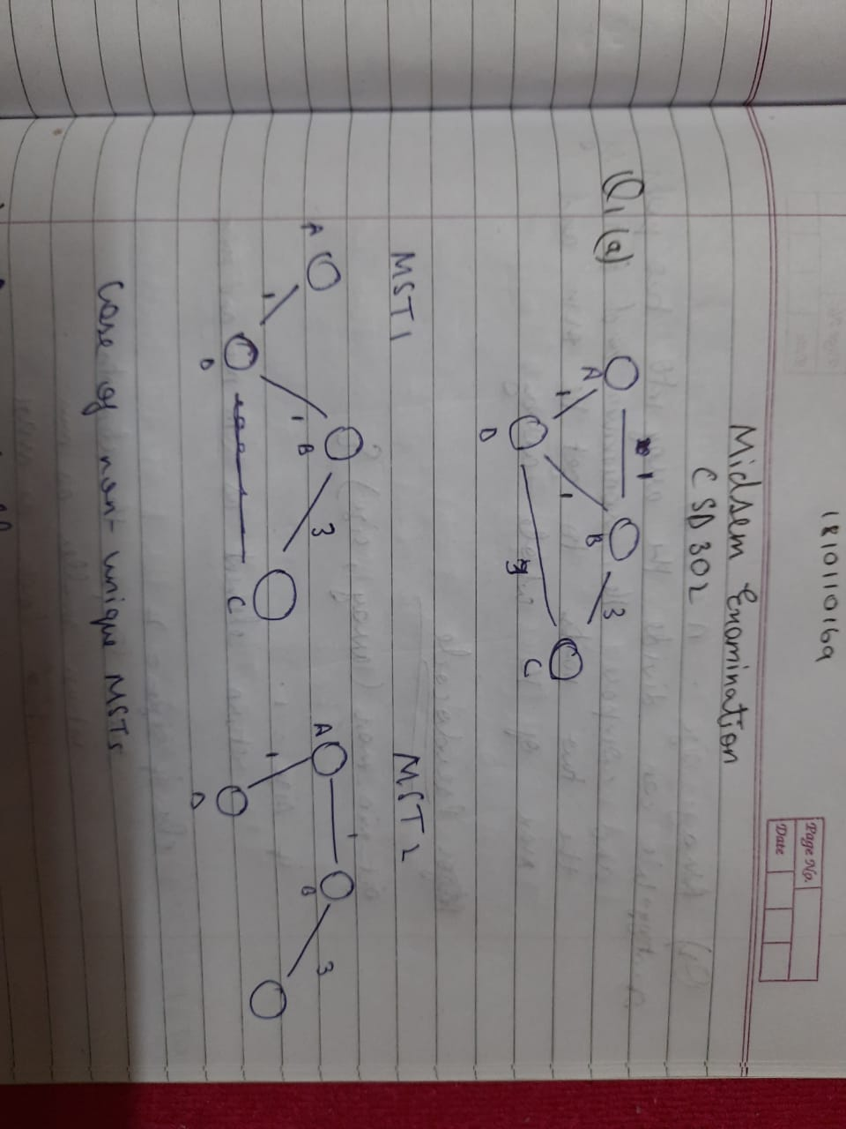

  - Given a connected graph G with n nodes and at least n edges. How would you remove an edge from G without disconnecting the graph?

Answer: Identify the edges which can form a cycle because there are n edges, there is bound to be at least one cycle in the graph. We can remove one of the edges from the cycle and the graph will still be connected. This is the way we can remove an edge from G without disconnecting the graph.

  - In a directed weighted graph, if the weight of each edges is increased by an integer a (where a >= 1), the shortest path always stays the same. (True/ False) – False

  - Any directed graph without cycles must have at least one vertex with in-degree 0 and at least one vertex with put degree 0. (True/ False) – True

  - Show briefly the greedy strategy used in Prim’s algorithm.

Answer: A greedy strategy is a strategy which is mostly used in optimization algorithms or finding the optimal paths. It consists of making the most optimal choice (usually including weights) at each step to get the final outcome. This condition is called the greedy property. Prim’s algorithm is a greedy algorithm because it creates the MST by adding the minimal weight edge from a vertex in the tree to a vertex not in tree. At each step, it picks up the edge which has the lowest weight thereby making the most optimal choice and hence, it is a greedy algorithm.

The second condition is the optimal substructure which means that the optimal solution for the problem also has to contain the optimal solutions for their sub-problems. This can be seen in the Prim’s algo. For each vertex, we find the lowest weight edge which means no matter what the size of the sub stricture, it will always be composed of the optimal solution because of the previous property since we are using a bottom up approach and greedy method.

Algorithm

- Create a set for vertices (VER) which keeps a track of vertices in the MST.
- Assign key value max to all vertices in the graph except the first one which is set to 0 so that it is picked first.
- While VER doesn’t include all vertices:
  - Pick a vertex u not in VER and has minimum key value
  - Add u to VER
  - Update key values of all the vertices adjacent to u – iterate through all the adjacent vertices and for every adjacent vertex v, if the weight of edge connecting u and v is less then than key value of v then update the key value of v with the edge weight.

  - If f(n) $≤$O(g(n)) and g(n) $≤$O(f(n)) then is f(n) = g(n) for all n? Justify your answer.

If f(n) is the worst case of g(n) and g(n) is the worst case of f(n) then they can be concluded to have equal complexity for all n.

  - Sort the following functions in the correct order from asymptotically smallest to asymptotically largest: log n, e^{n}, 2^{n}, n^{1/logn}, n!, n^{n}, $\sqrt{n}.$

n^{1/logn} , log n, $\sqrt{n}$, 2^{n}, e^{n}, n!, n^{n}

  - Amit and Bipasha are playing a game of numbers. Bipasha first thinks of an integer between 1 and 400. Amit must find out that number by asking Bipasha yes or no type questions. Bipasha never lies. Find out the minimum number questions that Amit has to ask within which he can always correctly tell the number Bipasha has thought of.

Answer: This question can be converted into a binary search problem to identify the number. Amit can ask questions like “Is the number greater than 200?”. If the answer is yes then he can eliminate numbers from 1 – 200. But he will also have to ask if the number is 200 or not?

Let’s assume she thinks of 400.
Questions:
- is it 200?
- Is it greater than 200?
- Is it 300?
- Is it greater than 300?
- Is it 350?
- Is it greater than 350?
- Is it 375?
- Is it greater than 375?
- Is the number 388?
- Is the number greater than 388?
- Is the number 394?
- Is the number greater than 394?
- Is the number 397?
- Is the number greater than 397?
- Is the number 399?
- Is the number 400?

The minimum number of questions is 16. This can be confirmed as 2 * (floor(log(400)). We multiply by 2 because we have to ask questions like Is it 200?

  - Consider the following C-like code, how many times stmt will be executed if we call the foo(10).
void foo (int n) {
if (n==0) {
stmt;
}
for (int i=0; i<=n-1;i*=2){
stmt;
}
}

Answer: This will run in an infinite for loop since. i*= 2 will always result in a 0.

  - Suppose P, Q, R, S, T are sorted sequences having lengths 20, 24, 30, 35, 50 respectively. They are to be merged into a single sequence by merging together two sequences at a time. How many comparisons will be needed in the worst case by the optimal algorithm for doing this? Justify.

We will use the binary heap method for this. In the worst case, we will need x + y – 1 comparisons because the last one can be inferred after the last comparison. If 1, 2 and 3 are compared, we only need two comparisons because the last element will be left out automatically. Here, x and y are the lengths of each array.

Total comparisons
20 + 24 – 1 = 43
30 + 35 – 1 = 64
44 + 50 – 1 = 94
65 + 94 – 1 = 158

Total = 358 comparisons

We take 44 and 65 as the sum of the first two comparisons i.e 24 and 20 and then 30 and 35. We then add it to the remaining array of comparisons i.e 50 and then check it with the sum of 30 and 35.

- Use a Divide and Conquer based approach to find the maximum and minimum element among a set of n numbers in 3n/2 comparisons. [Marks: 10]

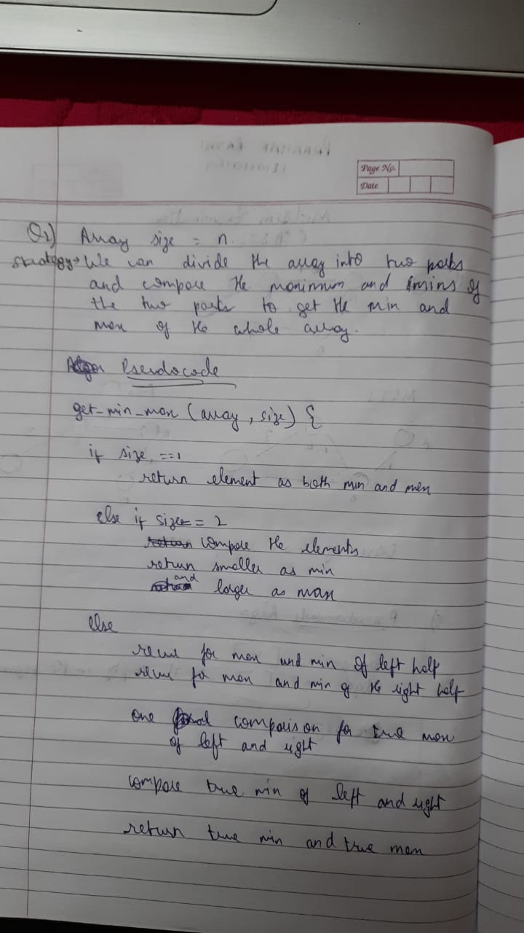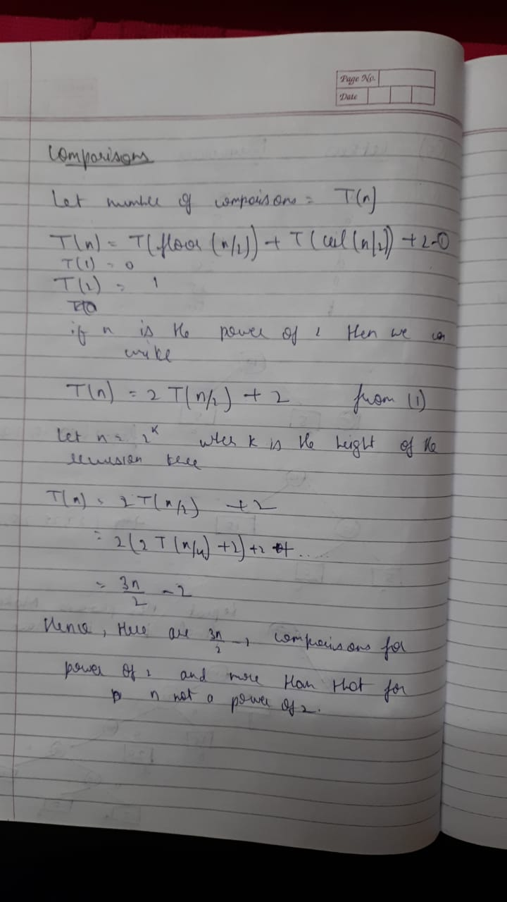

- Given the recurrence T($n)$ = T($α.n)$ + T$(β.n)$ + O($n)$, where 0<$α,β$ < 1. What value of $α,β$ensures that T(n) is O(n). Using this, conclude that the deterministic selection algorithm has O(n) running time. [Marks: 10]

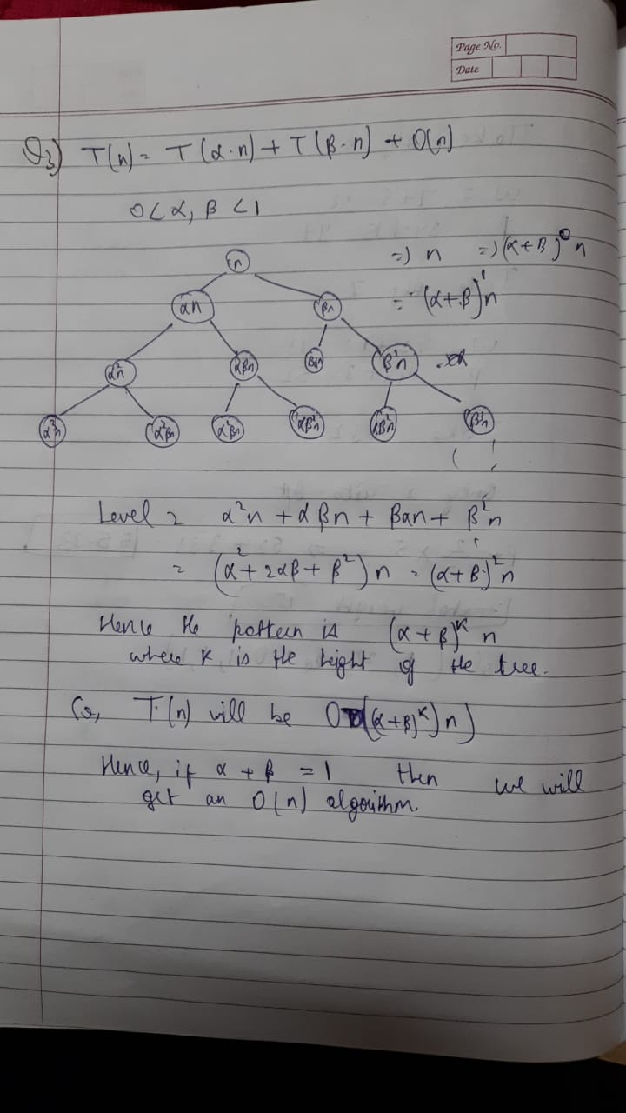

Do any two of the following questions (4, 5 and 6).
- What would be the time complexity of Prim’s algorithm? Show the step-by-step analysis. [Marks: 5]

- Suppose the letters a, b, c, d, e, f occur with following frequencies in a given text 5, 5, 15, 20, 25, 50 respectively. Show how much compression you achieved using Huffman codes compared to Uniform length code. [Marks: 5]

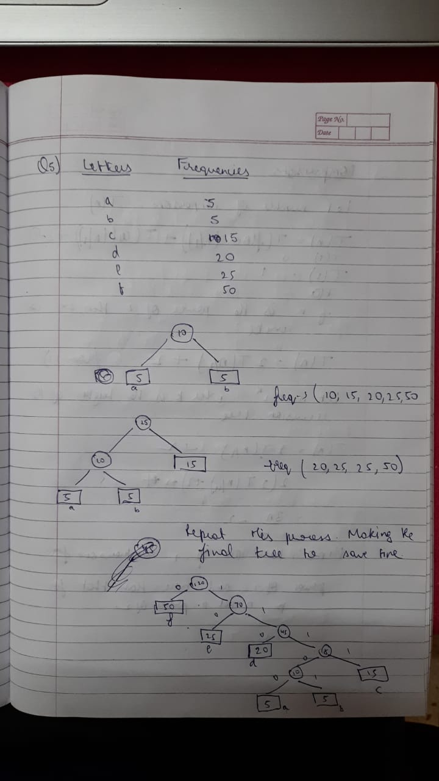

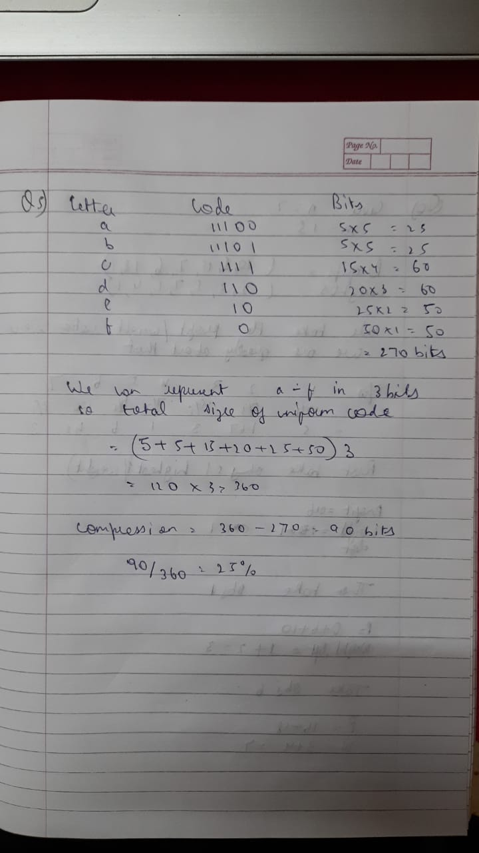

Compression by 25%

- Find an optimal solution to the knapsack where, n=7, m=15, (pl,p2.. ..p7)=(10,5,15,7,6,18,3,) and (wl,w2,.. ..,w7)=(2,3,5,7,1 ,4,1). [Marks: 5]

